Lecture 5
Internet Applications
For Chapters 9

Some of the materials in this lecture is not from your book. There are programs in language C in chapter 9. Let us stay with Java in the first half of the semester and devote the second half of the semester to C.

For Chapter 9
Internet Applications

In this chapter we look at of internet examples. We learn how to read the content of a remote file, how dynamically a server makes a page (an html document) to be displayed on the client browser. We first need the Apache HTTP Server which is the world's most used web server software. Since we are going to use servlets we also need: Apache Tomcat. Finally to be able to use a database manager we select: MySQL. All of these three software are collected in a server named: XAMPP. We also need a dialect of eclipse for Java EE developers that can handle Apache and Tomcat.

1. Installing eclipse for Java EE and XAMPP

To be able to turn your PC to a server and run the related program from eclipse we need a specific version of eclipse. Download this version from: http://www.eclipse.org/downloads/packages/release/neon/3

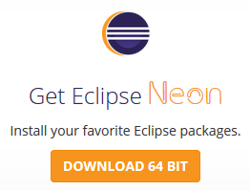

When you click on the download you are downloading the eclipse installer: 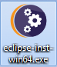
When you click on the installer the following page shows up:

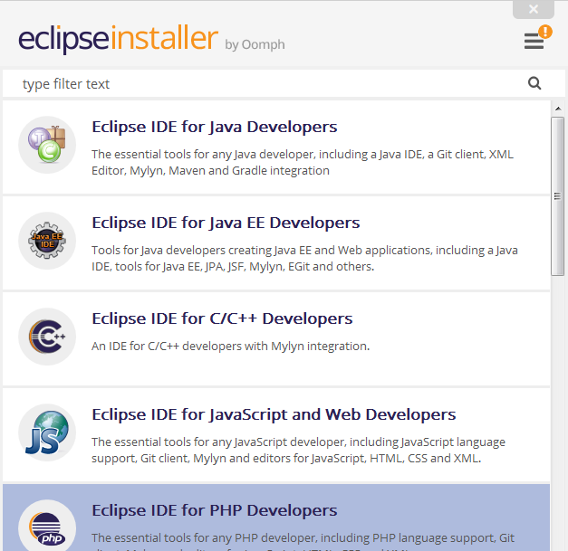

You need to install: Eclipse IDE for Java EE Developers.

You can remove other version(s) of eclipse from your computer.

Downloading and Installing XAMPP

1. Uninstall Apache if you have on your computer.
2. Uninstall MySQL if you have on your computer.
3. Go to the folder: Program Files and delete the folder Apache and MySQL
4. Reboot your computer.
5. Download the installer: xampp-win32-5.6.24-1-VC11-installer.exe from the following website to install: Apache, MySQL, Tomcat etc:
https://www.apachefriends.org/index.html
Note that this installer works for both 32-bits and 64-bits computer. If you have Mac download the version for mac.
Once you run the installer, you'll have c:\xampplite with a folder named: htdocs inside. Note that you can only have one copy of Apache and mySQL running at a time, so if you've installed them before, you'll need to at least stop them first.
After the installer is finished load XAMPP and start Tomcat:

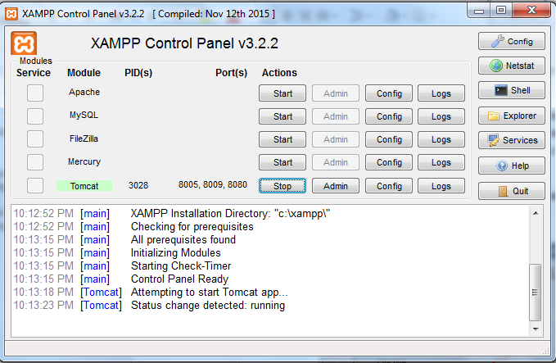
2. Testing

In this section we test the Tomcat, and

Example 1: To test Tomcat enter the following address tab of your browser:

http://localhost:8080/

You should see the following page:
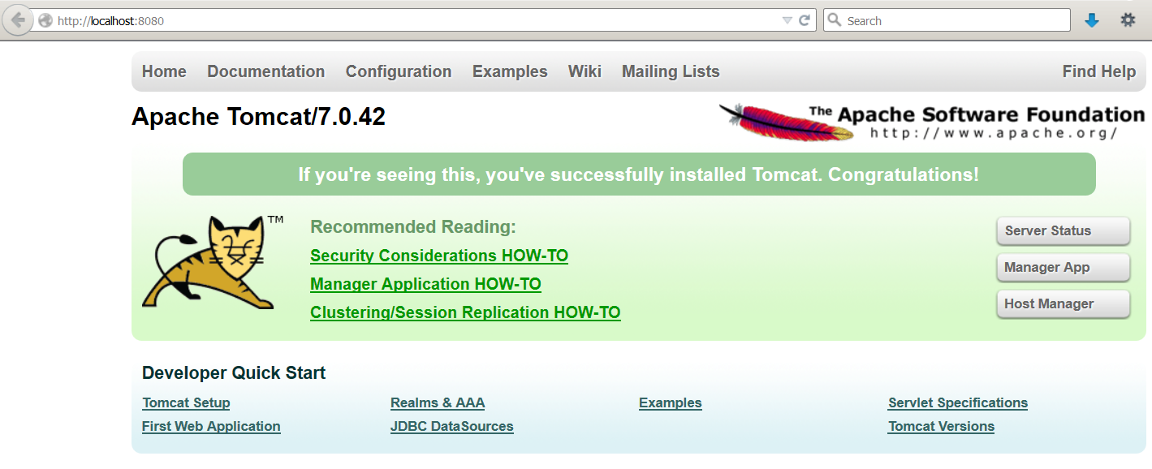

Stop Tomcat.

2. Uniform Resource Locator (URL)

A URL determines where a resource is in a computer on the network. Its syntax loosely is:

Protocol://IP:port_number/path?query_string

Protocol: A procedure for communication between two computers on the internet. The Hypertext Transfer Protocol (HTTP) is an example of a protocol.

IP: Address of a computer on the internet.

Port-number: This is a number associated with IP. The default port number is: -1. One of the port number we concentrate on in this lecture is: 8080. This port is used by http for web services.

Path: Path is used to specify where the resource is in a computer.

Query-string: The query string contains data to be passed to the server (we will see later in this lecture).

Example 2: The following program checks the syntax (format) of a URL:

import java.net.*;
import java.util.*;

public class Main {
public static void main(String[] args) {
Scanner keyboard = new Scanner(System.in);
System.out.print("Enter a URL: ");
try {
String name = keyboard.nextLine();
URL u = new URL(name);
System.out.println("The protocol is " + u.getProtocol());
System.out.println("The host is " + u.getHost());
System.out.println("The port is " + u.getPort());
System.out.println("The file is " + u.getFile());
} catch (MalformedURLException e) {
System.out.println("Error: " + e);
}
}
}

Output 1:
Enter a URL: http://pace.edu:500/Main
The protocol is http
The host is pace.edu
The port is 500
The file is /Main

Output 2:
Enter a URL: http://pace.edu/Main
The protocol is http
The host is pace.edu
The port is -1
The file is /Main

Output 3:
Enter a URL: http://pace.edu
The protocol is http
The host is pace.edu
The port is -1
The file is

Output 4:
Enter a URL: xyz://pace.edu
Error: java.net.MalformedURLException: unknown protocol: xyz

Output 5:
Enter a URL: http://localhost:8080/test.txt
The protocol is http
The host is localhost
The port is 8080
The file is /test.txt

Description:

The program does not check whether the URL is real or not. It only checks its syntax.
URL u = new URL(name): This instruction uses the java class: URL. It creates an object and lets the variable: u refers to it.
u.getProtocol(): Returns the protocol of the URL.
u.getHost(): Returns the IP (in non-numeric) of the computer.
u.getPort(): Returns the port number.
u.getFile(): Returns the name of the resource(file) the URL is referring to.

Output 1 http://pace.edu:500/Main. We have a complete URL.
Output 2: http://pace.edu/Main. We do not have the port number. The program displays its default which is: -1.
Output 3: http://pace.edu. We do not have the file: Main.
Output 4: xyz://pace.edu. The program jumps to the catch block and displays: Error: java.net.MalformedURLException: unknown protocol: xyz.

3. Reading data from a remote file

In this section, we look at two programs for reading a text file. The first one reads the files through a URL and the second uses sockets. First, we need to open an input stream to read the data from a file. An input stream is an object that inputs data. Next, we need to define a buffer to read the data from the file into this buffer and read from the buffer.

Example 3: The following program reads the lines of a file named: test.txt located on a URL and displays them. The content of the file: test.txt is:

This is the first line
This is the second line

Note: The program reads the file from the school server. To read the file from your computer:

1. Load on XAMPP.
2. Start Apache (and not Tomcat). For the school server you do not need this step.
3. To have a separate folder make a folder named: MyWork in: C:\xampp\htdocs.
4. Store test.txt in this folder.
5. In the following program change: "http://vulcan.seidenberg.pace.edu/mb~adii/test.txt" to: "http://localhost/MyWork/test.txt".

In the school server this file is in the folder: public_html in my account.
You can change: ~mbadii to your user name and copy this file in the folder: public_html of your account.

import java.net.*;
import java.io.*;

public class Main {
public static void main(String[] args) {
try {
//URL u = new URL("http://localhost/MyWork/test.txt");
URL u = new URL("http://vulcan.seidenberg.pace.edu/~mbadii/test.txt");
BufferedReader input=new BufferedReader(new
InputStreamReader(u.openStream()));
String s = input.readLine();
while (s != null){
System.out.println(s);
s = input.readLine();
}
} catch (MalformedURLException e) {
System.out.println(e);
} catch (IOException e) {
System.out.println(e);
}
}
}

Output:
This is the first line
This is the second line

Description:

This program is not using socket to connect to the server:

URL u = new URL("http://vulcan.seidenberg.pace.edu/~mbadii/test.txt"): See example 2.

BufferedReader input=new BufferedReader(new InputStreamReader(u.openStream())):
Creates an input buffer. The system does not read directly from the input stream. The system transfers data to the input buffer in blocks of fixed size (for example 512 characters).

String s = input.readLine(): Reads the first line of the file.

while (s != null){System.out.println(s); s = input.readLine();}: Reads the rest of the file.

Example 4: The following program is using sockets to display detailed information of the remote server and reads the content of a file named: test.txt from the server. This file must be stored in the folder: public_html in your school account.

Note: The program reads the file from the school server. To read the file from your computer:

1. Load on XAMPP.
2. In the window of XAMPP click on start of Apache.
3. To have a separate folder make a folder named: MyWork in: C:\xampp\htdocs.
4. Store test.txt in this folder.
5. In the following program change: "vulcan.seidenberg.pace.edu" to:

String host = "localhost".

6. In the following program change: "GET /~mbadii/test.txt HTTP/1.0\n\n" to:

"GET /MyWork/test.txt // HTTP/1.0\n\n"

import java.net.*;
import java.io.*;

public class Main {
public static void main(String[] args) {
try {
int port = 80;
String host = "vulcan.seidenberg.pace.edu";
Socket clientSocket = new Socket(host, port);
PrintWriter out = new PrintWriter(clientSocket.getOutputStream(), true);
String request = "GET /~mbadii/test.txt HTTP/1.0\n\n";
out.println(request);
BufferedReader in = new BufferedReader(new InputStreamReader(clientSocket.getInputStream()));
String response = in.readLine();
while (response != null) {
System.out.println(response);
response = in.readLine();
}
clientSocket.close();
}catch (Exception ex) {
System.out.println("ERROR : " + ex) ;
ex.printStackTrace(System.out);
}
}
}

Sample dialog

HTTP/1.1 200 OK
Date: Fri, 26 Feb 2016 04:40:57 GMT
Server: Apache/2.4.10 (Debian)
Last-Modified: Thu, 25 Feb 2016 18:20:22 GMT
ETag: "31-52c9c3c54d4a9"
Accept-Ranges: bytes
Content-Length: 49
Connection: close
Content-Type: text/plain

This is the first line.
This is the second line.

Description of the output:

The program reads from a file named: test.txt and displays its content on the console. The file has only the following two lines:

This is the first line.
This is the second line.

The previous lines of output show information about the server. These are:

HTTP/1.1 200 OK:
- HTTP/1.1: This protocol is the foundation for data transfer between a client and a server on the: World Wide Web (WWW).
- 200: The state code. This code means everything is: OK and there is no error. If we change the name of the file to a file name that does not exist (like: test2.txt) we get: HTTP/1.1 404 Not Found. In this case the state code is 404 to show there is an error and the error is file: Not Found.

To learn about status code such as 200, or 404 refer to:

http://www.w3.org/Protocols/rfc2616/rfc2616-sec10.html

Date: Fri, 26 Feb 2016 04:40:57 GMT: Date of the execution of this program.

Server: Apache/2.4.10 (Debian): The name of the server program is: Apache and the operating system on the server computer is: Debian which is a dialect of LINUX.

Last-Modified: Thu, 25 Feb 2016 18:20:22 GMT: The last time the file modified.

ETag: "31-52c9c3c54d4a9": Called: Entry tag to validate web cash (read page 246 for web cash).

Accept-Ranges: bytes: Servers informs the client that accepts requests in bytes.

Content-Length: 49: The file contains 49 characters including the carriage return, end-of-file, and space characters.

Connection: close: After the execution of the client program is finished the connection is closed.

Content-Type: text/plain: The content of the file is plain text (e.g. has no picture)

Description of the program

The idea in this program is to learn how the client requests from a server and how the server responds.

int port = 80: This port is for HTTP.
Socket clientSocket = new Socket(host, port): Creates socket object and connects to the: host at specified: port.
PrintWriter out = new PrintWriter(clientSocket.getOutputStream(), true):
Creates a PrintWriter object to be able to send (write) request (a string) to the server.

String request = "GET /~mbadii/test.txt HTTP/1.0\n\n": To request the content of the file: test.txt using the protocol: HTTP/1.0.

Note: To run the program on your school server account change: mbadii to your user name.

There are two HTTP methods to accomplish this request:
- GET: To retrieve (get) the contents of the web documents.
- POST: To send data to the server.

For more detail on GET and POST refer to: http://www.w3schools.com/TAGS/ref_httpmethods.asp

Both GET and POST brings the same data from the server to the client. The difference between GET and POST is clearer when we send an html document to the server. An html document contains command buttons, text boxes, and radio buttons, etc. objects. Each object has a name and a value (content). A browser send the sequence of these (name, value)’s to the server. When GET method is use these pairs are visible in the location bar of the browser. But with the POST method they are not visible.
out.println(request): Sends (write) the request: "GET /~badii/test.txt HTTP/1.0\n\n" to the server.

String response = in.readLine(): The server responds. The program one line from the file: test.txt which is on the server.

while (response != null){System.out.println(response);response = in.readLine();}: Keeps displaying and reading all the lines of the file: test.txt.

The program gets even easier if we are not interest in the detail of the server and we only like to see the content of the file. In this case we use the class URL in place of socket.

Example 5: The following program reads the content of a file named: test.txt from a server, but does not display the information about the server. Note that this program is not using a socket to communicate with the server. Therefore using a socket in a request-respond procedure is not necessary.

import java.net.*;
import java.io.*;

public class Main {

public static void main(String[] args) {
try {
URL theURL = new URL("http", "vulcan.seidenberg.pace.edu", 80, "/~mbadii/test.txt");
BufferedReader in = new BufferedReader(new InputStreamReader(theURL.openStream()));
String response = in.readLine();
while (response != null) {
System.out.println(response);
response = in.readLine();
}
}catch (Exception ex) {
System.out.println("ERROR : " + ex) ;
ex.printStackTrace(System.out);
}
}
}

Sample dialog

This is the first line.
This is the second line.

Description

Only the following instruction is new. The rest are in the program of example 4.

URL theURL = new URL("http", "vulcan.seidenberg.pace.edu", 80, "/~mbadii/test.txt"): This creates an object of the type class: URL with one of its constructors. The first argument specifies the protocol. The second one is the host address, the third one is the port number in the server, and the last one is the file name and the user name.

With HTTP1.0, a connection to a server is automatically closed as soon as the server returns a response. Thus exactly one round of exchange is allowed between a client and a web server; if a client needs to contact the same server in another session, it must reconnect to the server to reissue another request. The scheme is adequate for the original intent of HTTP for retrieving simple network documents. It is inefficient for documents such as those that contain a large number of links to image objects to be fetched by the server, since fetching each of these links require a reestablishment of a connection.

With the following concepts we can send and receive data more elegantly.

4. Dynamically Generated Web Content using Common Gateway Interface

Eclipse is one of the most convenient IDE to handle servlets. Data moves between a client program to a server program using sockets, URLs, and servlets, JSP (Java Server Page), etc. A Java servlet is a Java Objects that extends the capabilities of a server. This object can receive a request and generates a response based on that request.
Since we like to include html code in a java program, we need an IDE to be able to run and debug our program. Eclipse is the vehicle for our work.
Note: If you are using any other IDE you need to either switch to eclipse or learn how to use your IDE for the following material and through the end of the course.

In the rest of this section we will cover:

1. Creating an Apache Tomcat server.
2. Creating a dynamic Web project
3. Creating an HTML document.
5. Creating a Servlet.

4.1. Creating an Apache Tomcat server

When we create server, a dynamic web project, an html and/or a servlet via eclipse we must stop every module and quit XAMPP:

1. Create an empty folder and load eclipse for this folder. Do not make a java project.
On the menu bar click: New → Other → Server → Server to see:

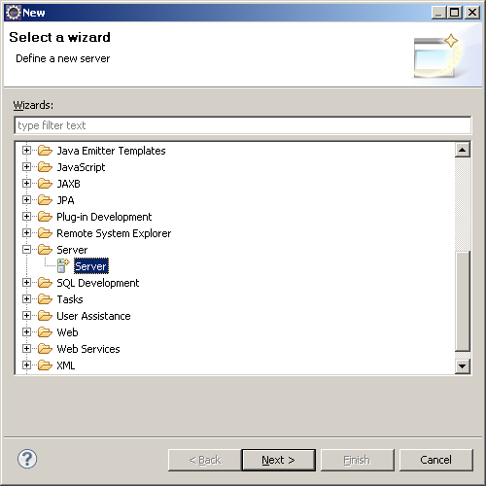

Click: Next.

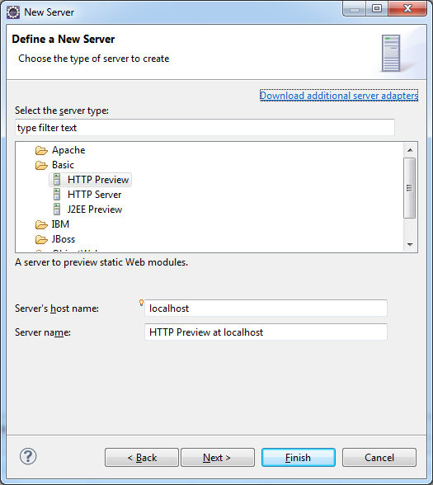

Expand the icon Apache and select Tomcat v7.0 Server to see:

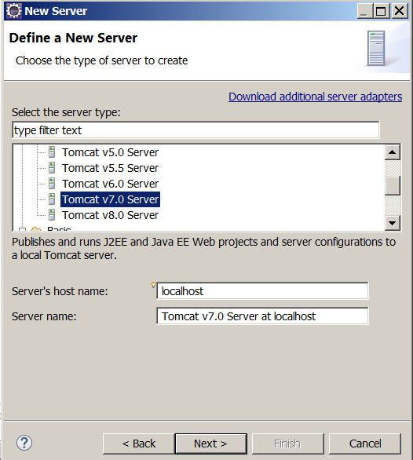

2. Click Next:

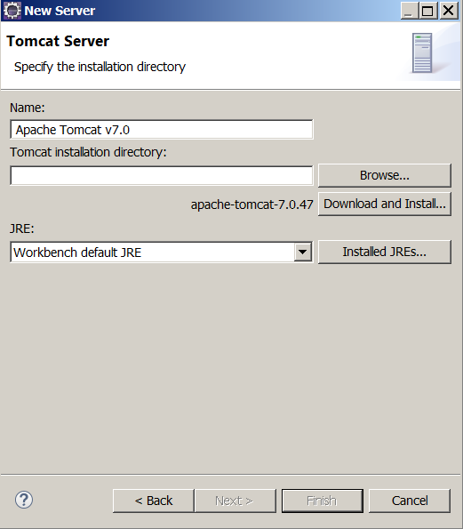

3. Browse, find and insert the path of Tomcat 7.0 to see:

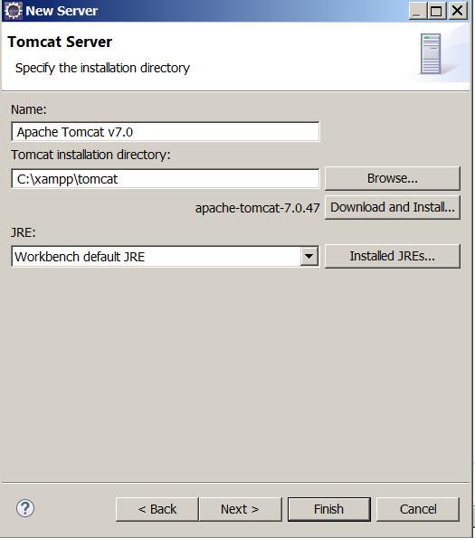

4. Click Finish. The Project Explorer should be:

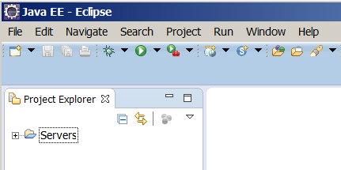

4.2. Creating a dynamic Web project

1. Click File → New → Other → Web → Dynamic Web project:

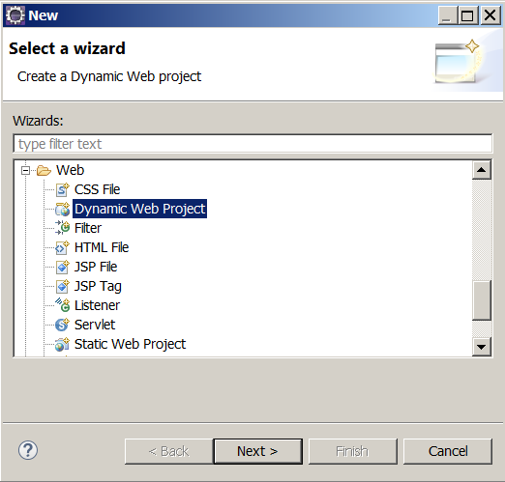

2. Click: Next and name this project. I named it: Project
Note: The name of the dynamic project should be one word.
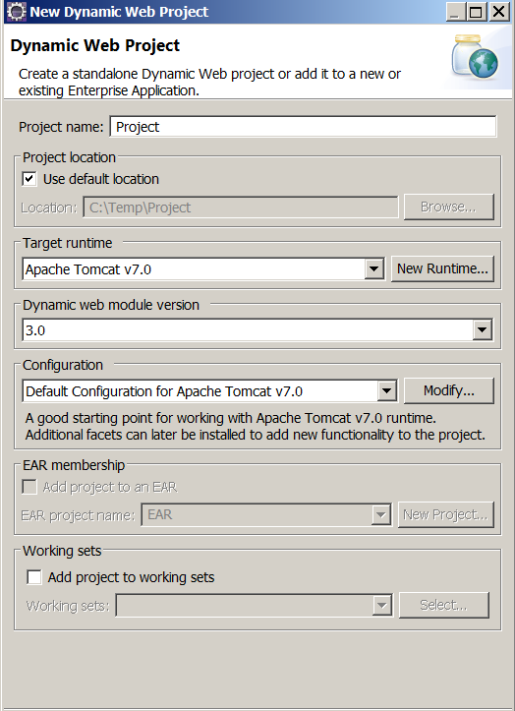

3. Click: Finish. The eclipse editor should be:

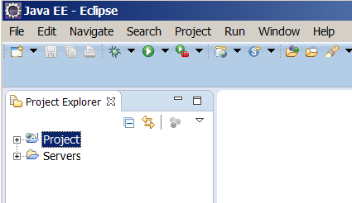

Note: Creating a server and a dynamic project is a must be for HTMLs, and Servlets.

4.3. Creating an HTML document

In this section we create a simple html document in eclipse.

Example 6: The following steps create an html document that displays the message: Hello there.

1. In the Project Explorer, expand your project to see:

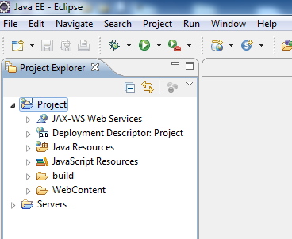

2. Right click on the folder: WebContent and click on: New to see:

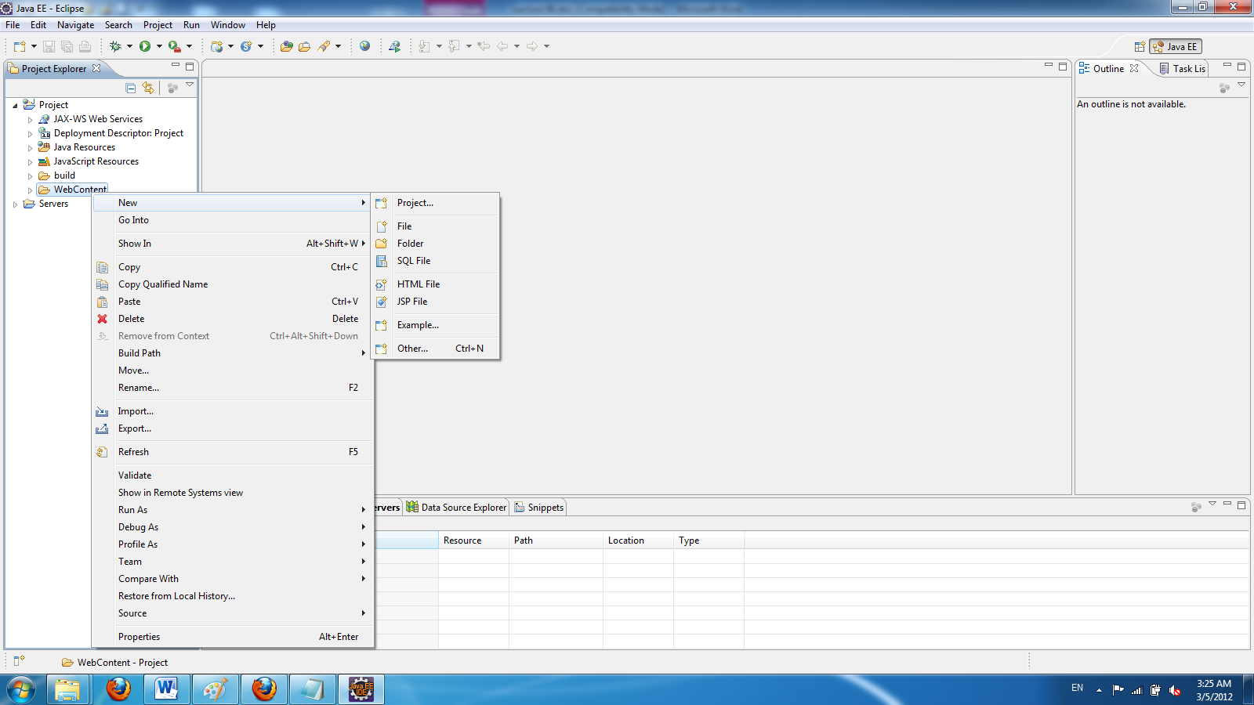

3. Click on HTML File page to see:

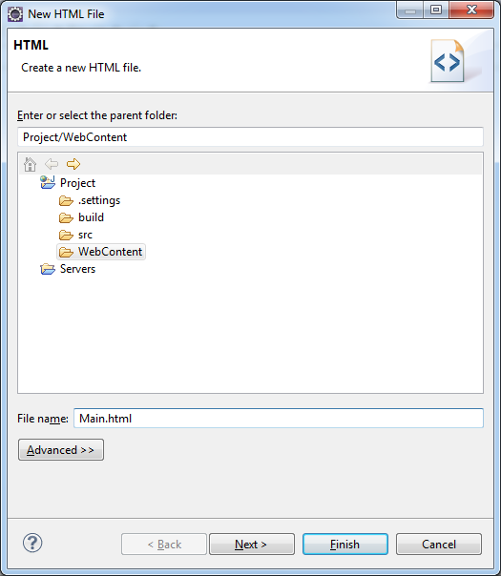

4. Enter a file name (I named it Main.html) and click Finish. The content of the editor is:

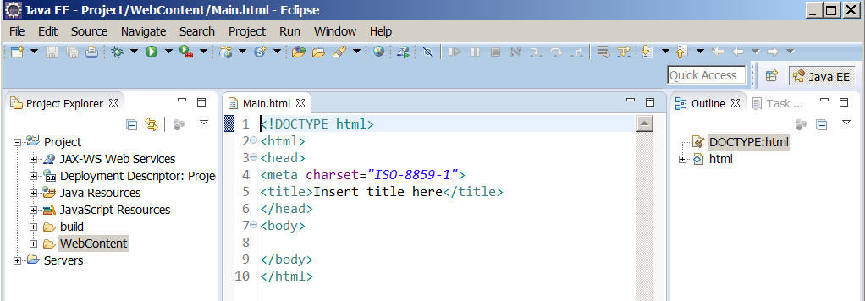

5. Replace the content of the editor by:

<html>
<head>
<meta http-equiv="Content-Type" content="text/html; charset=ISO-8859-1">
<title>Hello</title>
</head>
<body>
<h1>Hello there ! </h1>
</body>
</html>
Note: If tomcat is running, stop it.
5. Click on run icon to see:

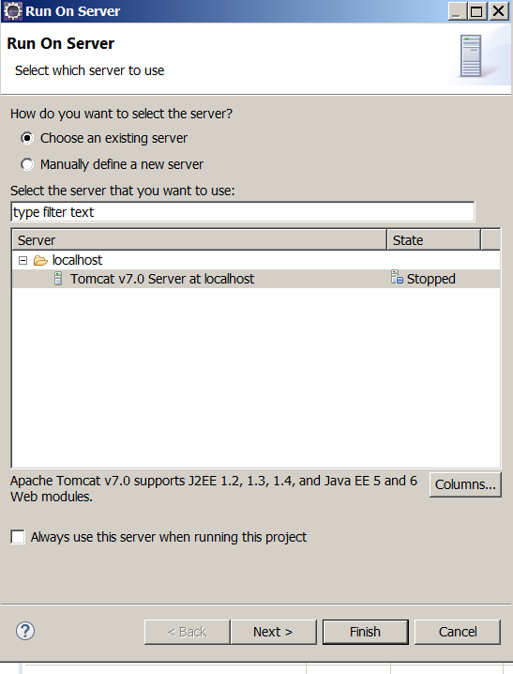

6. Select Tomcat v7.0 server and click on: Finish to see:

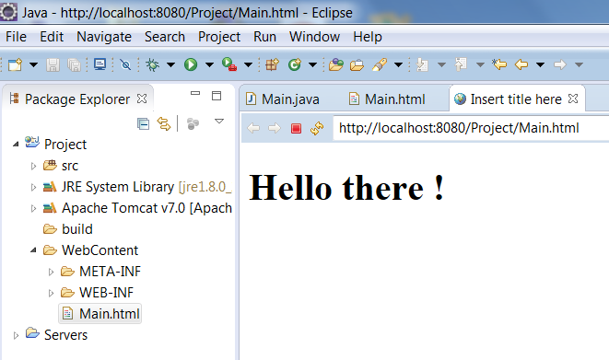

7. Stop the tomcat server by clicking on the small red rectangle on the lower window (from: console window). Close the html page.
Note: Click on: to refresh the page if the you had a different html and copy/paste the new html document over the old one.

4.4. Creating a Servlet

In this section we create a servlet for the server side.

Example 7: We like to make a servlet to send an html document to the client side. This document is made dynamically. The html document displays: Hello there.

1. In the Project Explorer, expand your project and right click on WebContent → New → Others to see:
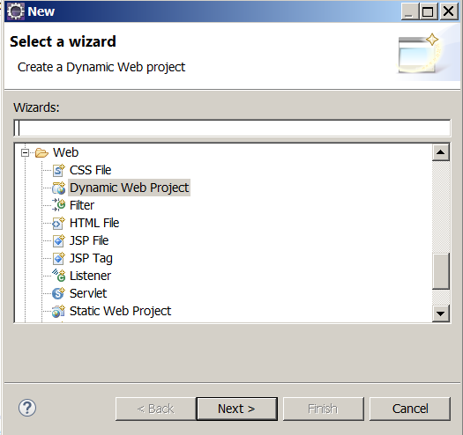

2. Select Servlet and click Next:

3. Enter a class name (I entered Main):

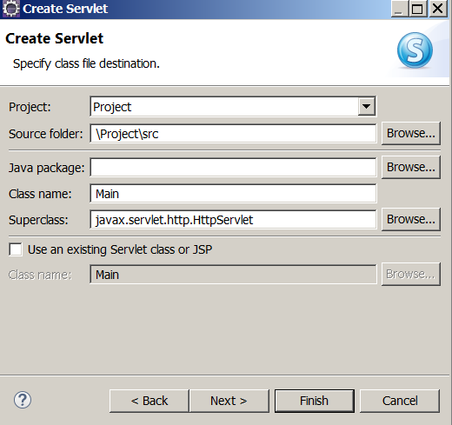

Note: Since you have only one class there is no need to have a package. Therefore leave the package window blank.

4. Click Finish. The content of the editor should be:

import java.io.IOException;
import javax.servlet.ServletException;
import javax.servlet.annotation.WebServlet;
import javax.servlet.http.HttpServlet;
import javax.servlet.http.HttpServletRequest;
import javax.servlet.http.HttpServletResponse;

/**
* Servlet implementation class Main
*/
@WebServlet("/Main")
public class Main extends HttpServlet {
private static final long serialVersionUID = 1L;

/**
* @see HttpServlet#HttpServlet()
*/
public Main() {
super();
// TODO Auto-generated constructor stub
}

/**
* @see HttpServlet#doGet(HttpServletRequest request, HttpServletResponse response)
*/
protected void doGet(HttpServletRequest request, HttpServletResponse response) throws ServletException, IOException {
// TODO Auto-generated method stub
}

/**
* @see HttpServlet#doPost(HttpServletRequest request, HttpServletResponse response)
*/
protected void doPost(HttpServletRequest request, HttpServletResponse response) throws ServletException, IOException {
// TODO Auto-generated method stub
}

}

5. Replace this program with the following and run it:

import java.io.IOException;
import java.io.PrintWriter;
import javax.servlet.ServletException;
import javax.servlet.annotation.WebServlet;
import javax.servlet.http.HttpServlet;
import javax.servlet.http.HttpServletRequest;
import javax.servlet.http.HttpServletResponse;

@WebServlet("/Main")
public class Main extends HttpServlet {
private static final long serialVersionUID = 1L;

public Main() {
super();
}

protected void doGet(HttpServletRequest request, HttpServletResponse
response) throws ServletException, IOException {
PrintWriter out = response.getWriter();
out.println("<html><title>Hello</title><body>\n");
out.println("<font color = blue>");
out.println("<h1>Hello there!</h1>\n");
out.println("</font>");
out.println("</body></html>");
out.close();
}
}

You should see:

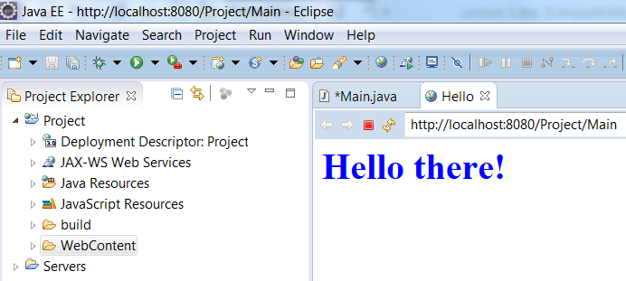

Note: This is a java class. You should not get any error.

Note: Always click on the tab: Console to make sure no other program is running. If you have a situation like the following screen shot click on the small red button to stop a program:

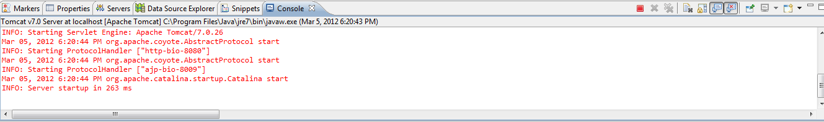

As we notice from the previous example HTTP can transfer static contents like the content of a text file or an image. We also can allow a browser to retrieve information in a database on the server side. For example, when a user enters a credit card number and submits to the server we can have a program that checks in a database to find out whether or not the number is in the list of credit card numbers. The server can dynamically make an html document and display the client browser to inform the credit card is valid or invalid.

Exercise 1: Write a servlet displays: Hello there! or displays: Have a good night on a web page. The program should prompt the user on the console: Enter: yes to display: Hello there or enter no to display: Have a good night.

Exercise 2: Write a servlet that counts how many times the program is executed provided not to stop the server.

A Web Form

The examples in the book are in C. I rather prefer Java at this stage. I am assuming you have installed and tested the Apache. For the client side we design an html document that contains the html tag: form to be able to submit the page to the server program.

Example 8: The following is a simple html document with a tag form:

<html>
<head>
<meta http-equiv="Content-Type" content="text/html; charset=ISO-8859-1">
<title>A simple example</title>
</head>
<body>
<form action="http://localhost:8080/Project/Main" method = "get">
Enter Your Name: <input type="text" name="yourName"><br>
Enter Your Age&nbsp;&nbsp;&nbsp;&nbsp;:<input type="text" name="yourAge"><br>
<input type="submit" value="Click to submit">
</form>
</body>
</html>

Note: The name: Project should exactly be the same as the name of the eclipse dynamic project.
When we make an html document in eclipse (similar the way I explained for installing a servlet class) this page displays:

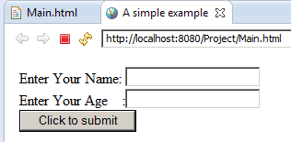

This html document has three objects: Two text boxes and a command button. Each object has a name and value. When we click on the submit button a sequence of these pairs (name, value) are sent to the server program. The line:

<form action="http://localhost:8080/Project/Main" method = "get">

Specifies that the file: Main.class in in the folder: Project\build\classes. I named the eclipse project: Project. The segment: method = "get" instructs the server to executed the method: doGet. Let us define this method in the servlet class Main:

import javax.servlet.ServletException;
import javax.servlet.annotation.WebServlet;
import javax.servlet.http.HttpServlet;
import javax.servlet.http.HttpServletRequest;
import javax.servlet.http.HttpServletResponse;
import java.io.*;
import java.util.Enumeration;
@WebServlet("/Main")
public class Main extends HttpServlet {
private static final long serialVersionUID = 1L;
public Main() {
super();
}

protected void doGet(HttpServletRequest request, HttpServletResponse
response) throws ServletException, IOException {
Enumeration<String> names = request.getParameterNames();
while (names.hasMoreElements() ){
String name = (String)names.nextElement();
String value = request.getParameter(name);
System.out.println("(" + name + ", " + value + ")");
}
}
}

Display output:

We run the html document and enter: Jon Doe and 45 for the name and age:

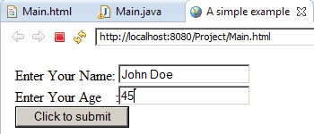

Now we click on the submit button the following page shows up:

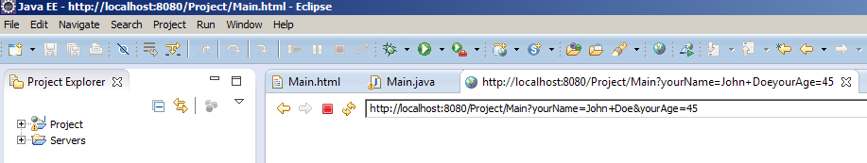

Then the method: doGet of Main.java gets executed and displays the following pairs on the console:

(yourName, John Doe)
(yourAge, 45)

5. Creating and using cookies

Cookies are used to store a small amount (4K) of information on the client’s computer. The server can track a client’s computer to find out whether or not the client has been contacting before. The javax.servlet.http contains a Cookie class that allows you to quickly set up and process HTTP cookies. In other words, the server sends a cookie to a browser to be stored in the client computer with some attributes such as a comments, path, a maximum age, and a version number. If the client next time makes a new connection and makes request the server can access the cookie (which is stored in the client’s computer) to find the information that has been stored previously. Cookies can be made to save the user names and passwords. In this case, the user does not have to enter username/password when she/he wants to request from the same server.

A servlet program can create a cookie object by: new Cookie(name, value) and adds the cookie by calling: addCookie(cookie) to the browser’s space on the client’s computer. If the client requests from the same server the server reads the client’s cookies by calling: getCookies(). Some methods that are useful in processing cookies are: getCookies(), getName(), getValue(), setValue(aString), setMaxAgeint (anInteger), setPath(URI), getPath(),getDomain( ), and setDomain(aDomain) to retrieve, get the name, get the value, set the value, set the maximum age in seconds, specify path, get the path, get the domain, and to set the domain of a cookie respectively.

You can delete one or all the cookies from your window. For example in the IE or Firefox browser we hit Ctrl-Shift-Delete to delete cookies.

Example 9: The following program sends a cookie to a client.

A: The html document:

<!-- Main.html -->
<!DOCTYPE html PUBLIC "-//W3C//DTD HTML 4.01 Transitional//EN" "http://www.w3.org/TR/html4/loose.dtd">
<html>
<head>
<meta http-equiv="Content-Type" content="text/html; charset=ISO-8859-1">
<title>Servlet Example</title>
</head>
<body>
<form action="http://localhost:8080/Project/Main">
<center>
<br><br>
<input type="submit">
</center>
</form>
</body>
</html>

B: The servlet:

import java.io.*;
import javax.servlet.ServletException;
import javax.servlet.annotation.WebServlet;
import javax.servlet.http.HttpServletRequest;
import javax.servlet.http.HttpServletResponse;
import javax.servlet.http.Cookie;

@WebServlet("/Main")
public class Main extends javax.servlet.http.HttpServlet implements javax.servlet.Servlet {

public Main() {
super();
}

protected void doGet(HttpServletRequest request,
HttpServletResponse response)throws ServletException, IOException {
Cookie aCookie = new Cookie("myName", "myValue");
aCookie.setMaxAge(60*60*24*365); // 1 year
response.addCookie(aCookie);
response.setContentType("text/html");
PrintWriter out = response.getWriter();
out.println("<html>\n" +
"<head><title>Processing Cookies</title></head>\n" +
"<body bgcolor=\"#fdf5e6\">\n" +
"<h1 align=\"center\"> Thanks I will remember you</h1>\n" +
"</body></html>");
}
}

When you click on the submit button:

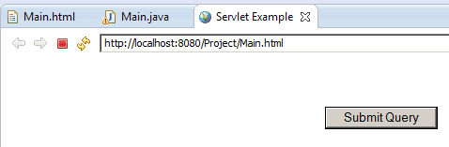

You get the following page.

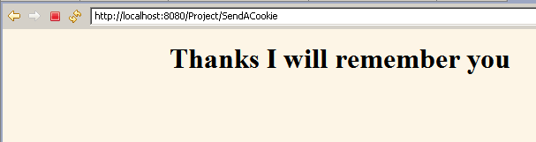

Description:

The instruction:

Cookie aCookie = new Cookie("myName", "myValue");

Creates a Cookie object and passes the name myName and the value myValue to the object through the constructor. Note that the value also is a string.
Note: In your project you will have different strings for name and value. You cannot choose myName for name and myValue for value. These strings comes from textboxes of an html document. Therefore you must not have quotations (i.e. ") when creating a new cookie.

The instruction:

aCookie.setMaxAge(60*60*24*365);

Means the cookie in the client computer is stored for a year by the next instruction (provided the user do not delete it !).
Note: To remove a cookie via your java program write:

aCookie.setMaxAge(0);

Finally the instruction:

response.addCookie(aCookie);

Adds the cookie to the client computer.

We can track a client by a cookie that has been stored to his/her computer before.

Example 10: The following servlet checks if a client has been visited the server.

Note: We use the html document of the previous example.

B: The servlet:

import java.io.IOException;
import java.io.PrintWriter;
import javax.servlet.ServletException;
import javax.servlet.annotation.WebServlet;
import javax.servlet.http.Cookie;
import javax.servlet.http.HttpServletRequest;
import javax.servlet.http.HttpServletResponse;

@WebServlet("/Main")
public class Main extends javax.servlet.http.HttpServlet implements javax.servlet.Servlet {

public Main() {
super();
}

protected void doGet(HttpServletRequest request, HttpServletResponse response)
throws ServletException, IOException {
boolean found = false;
String message = "Thank you for visiting us again";
Cookie[] cookies = request.getCookies();
if (cookies != null && cookies.length > 0)
for(int i=0; i<cookies.length; i++) {
Cookie c = cookies[i];
if ((c.getName().equals("myName")) && (c.getValue().equals("myValue"))){
found = true;
break;
}
}
if(! found)
message = "I am sorry you have not visited us before.";
response.setContentType("text/html");
PrintWriter out = response.getWriter();
out.println("<html>\n" +
"<head><title>Processing Cookies</title></head>\n" +
"<BODY BGCOLOR=\"#FDF5E6\">\n" +
"<h1 alighn\"center\">" + message + "</h1>\n" +
"</body></html>");
}
}

If you have not deleted the cookies through IE browser and click on the Submit button you get the following page:

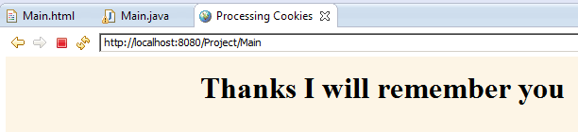

On the other hands if you have deleted cookies (Ctrl-Shift-Delete) you get the following page:

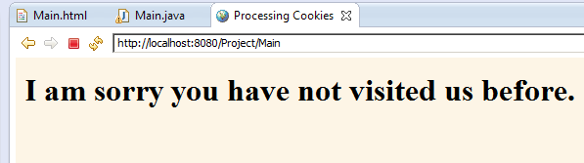

Description: In the server the instruction:

Cookie[] cookies = request.getCookies(): Accesses all the cookies from the client computer.

Provided there are cookies, the for-loop:

for(int i=0; i<cookies.length; i++) {
Cookie c = cookies[i];
if ((c.getName().equals("myName")) && (c.getValue().equals("myValue"))){
found = true;
break;
}
}

The loop looks for a specific cookie by the name "myName" and the value "myValue". If there is such a cookie changes the value of the variable: found to true and the control of execution breaks out of the loop.

Now the following conditional statement is executed:

if(! found)
message = "I am sorry you have not visited us before.";

Since the condition evaluates to: false the content of the variable: message won’t change and the program issues the message: "Thank you for visiting us again".
If the cookie is not available the above for-loop takes all its iterations and the control of execution goes after the loop and execute the above conditional statements. Since the value of the variable: found is false the condition is evaluated to true and the content of variable: message is changed to:

message = "I am sorry you have not visited us before.";

The control of execution then makes a dynamic html document and writes (out.println…) to display appropriate page on the client’s browser.

